GENERAL CONFEDERATION OF LABOR OF VIETNAM

**TON DUC THANG UNIVERSITY**

**FACULTY OF INFORMATION TECHNOLOGY**



# **WEB PROGRAMMING AND APPLICATION**

**FINAL REPORT**

*Instructing Lecturer:***Mr. Phạm Văn Huy**

*Student’s name:***Trần Phạm Anh Tuấn – 517H0093**

**Tô Quốc Thắng – 517H0082**

Class **: 17050210**

Course  **: 21**

**HO CHI MINH CITY, YEAR 2020.**

GENERAL CONFEDERATION OF LABOR OF VIETNAM

**TON DUC THANG UNIVERSITY**

**FACULTY OF INFORMATION TECHNOLOGY**



**WEB PROGRAMMING AND APPLICATION**

**FINAL REPORT**

*Instructing Lecturer:* **Mr. Phạm Văn Huy**

*Student’s name:* **Trần Phạm Anh Tuấn – 517H0093**

**Tô Quốc Thắng – 517H0082**

Class **: 17050210**

Course  **: 21**

**HO CHI MINH CITY, YEAR 2020.**

# **ACKNOWLEDGEMENT**

In order to make this report complete and achieve good results, we have received the support and assistance of teachers and classmates.

With deep affection, sincerity, we express deep gratitude to all individuals and agencies who have helped us in our study and research.

First of all, I would like to express a special appreciation to Ton Duc Thang University’s teachers for their conscientious guidance and advices throughout the last semester by gave me their modern outlook and meticulous supervision to carry out the job perfectly.

Especially we would like to send our sincere thanks to Mr. Pham Van Huy has paid attention, help, guide us to complete the report well over the past time.

We would like to express our sincere gratitude to the leadership of Ton Duc Thang University for supporting, helping and facilitating us to complete the report well during the study period.

With limited time and experience, this report can’t avoid mistakes. We are looking forward to receiving advice and comments from teachers so that we can improve our awareness, better serve the practical work later.

We sincerely thank you!

# **THIS PROJECT WAS ACCOMPISHED AT TON DUC THANG UNIVERSITY**

I pledge that this is a product of our own project and is under the guidance of Mr. PHAM VAN HUY. The content of research, results in this subject is honest and not published in any form before. The data in the tables used for the analysis, comment, and evaluation were collected by the authors themselves from various sources indicated in the reference section.

**If any fraud is found, I am fully responsible for the content of my project.** Ton Duc Thang University is not involved in any copyright infringement or copyright infringement in the course of implementation (if any).

*Ho Chi Minh City, June 29th 2020*

*Author*

*(Sign and write full name)*

*TO QUOC THANG*

*TRAN PHAM ANH TUAN*

# **EVALUATION AND INSTRUCTION LECTURER**

**Confirmation of the teacher instructor**

_________________________________________________________

_________________________________________________________

_________________________________________________________

_________________________________________________________ _________________________________________________________

_________________________________________________________

Ho Chi Minh City, June 29th 2020

(Sign and write full name)

**The assessment of the teacher marked**

_________________________________________________________

_________________________________________________________

_________________________________________________________

_________________________________________________________ _________________________________________________________

Ho Chi Minh City, June 29th 2020

(Sign and write full name)

**Table of contents:**

**WEB PROGRAMMING AND APPLICATION** i

**ACKNOWLEDGEMENT** iii

**THIS PROJECT WAS ACCOMPISHED AT TON DUC THANG UNIVERSITY** iv

**EVALUATION AND INSTRUCTION LECTURER** v

**Table of contents:** 6

**I.** **INTRODUCTION:** 7

**1.** **Why we choose this topic:** 7

**II.** **DATABASE:** 7

**1.** **ER DIAGRAM:** 7

**2.** **TABLE STRUCTURE:** 8

**2.1** **Table products:** 8

**2.2** **Table loaisanpham:** 8

**2.3** **Table chitiet_donhang:** 9

**2.4** **Table donhang:** 9

**2.5** **Table Customer:** 10

**2.6** **Table datban** 10

**2.7** **Table slide:** 11

**III.** **TNT PIZZA:** 11

**IV.** **General conclusion wordpress:** 11

**V.** **REFERENCES:** 11

1. **INTRODUCTION:**
2. **Why we choose this topic:**

Because we have interest about and want to share our fun to erveryone. We decide to create a website that sell pizza online and order table at our restaurant so that everyone can find out what is special about an Pizza we bring to them!

Our website is here:

1. **Open source code:**

LAVAREL.

1. **DATABASE:**
2. **ER DIAGRAM:**

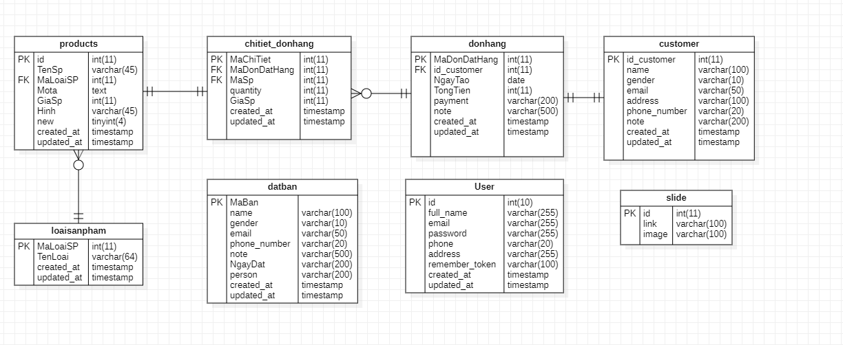

1. **TABLE STRUCTURE:**
   1. **Table products:**

**a/ Primary Key:**

* id: use to identify each product on our website.

**b/ Foreign Key:**

* MaLoaiSP: use to conect with table loaisanpham to set type of that product.

**c/ Other Field:**

* TenSP: show name of product.
* Mota: decription about that product for other information like ingredients for cooking
* GiaSP: show price of product.
* Hinh: picture about product.
* New: to identify new product of restaurant.

**d/ Table specification:**

Table attach with home page of website to show our product to customer and information about that product.

* 1. **Table loaisanpham:**

**a/ Primary Key:**

* MaLoaiSP: to identify each product

**b/ Foreign Key:**

* Don’t have Foreign Key.

**c/ Other Field:**

* TenLoai: to show which type of that product

**d/ Table specification:**

Table show type of our product.

* 1. **Table chitiet_donhang:**

**a/ Primary Key:**

* MaChiTiet: use to identify each product when customer order pizza online.

**b/ Foreign Key:**

* MaDonDatHang: use to connect with table **donhang**.
* MaSP: connect with MaLoaiSp in table **products**

**c/ Other Field:**

* quantity: number of pizza customer order online.
* GiaSp: total price what customer must pay to complete order.

**d/ Table Specification:**

This table connect with table **donhang** to help admin can manager order

* 1. **Table donhang:**

**a/ Primary Key:**

* MaDonDatHang: connect with field MaDonDatHang of table **chitiet_donhang** to show each product in order will buy by customer

**b/ Foreign Key:**

* id_customer: connect with table **customer** to save information of customer.

**c/ Other Field:**

* NgayTao: day of order was created.
* TongTien: total price the customer must pay to complete the order.
* Payment: the way customer want to pay the order.
* Note: note of customer want to our restaurent to attentive.

**d/ Table Specification:**

Table can show what type of payment, total price , product of the order

* 1. **Table Customer:**

**a/ Primary Key:**

* id_customer: use to identify customer information.

**b/ Foreign Key:**

* Don’t have.

**c/ Other Field:**

* Name: name of customer.
* Gerder: sex of customer.
* Email: email of customer.
* Address: place customer want to take the food when they order online.
* Phone_number: phone number of customer.
* Note: note of customer.

**d/ Table Specification:**

This table will save information of customer.

* 1. **Table datban**

**a/ Primary Key:**

* MaBan: to identify place of that table in restaurant.

**b/ Foreign Key:**

* Don’t have.

**c/ Other Field:**

* Name: name of customer.
* Gender: gender of customer.
* Email: emiaal of customer.
* Phone_number: phone number of customer.
* Note: note of custome want restaurant to attentive.
* Ngaydat: day customer arraive to restaurant.

**d/ Table Specification:**

This table save information of customer want to book table thought our wabsite.

* 1. **Table slide:**

**a/ Primary Key:**

* id: to identify each picture show on banner in homepage.

**b/ Foreign Key:**

* Don’t have.

**c/ Other Field:**

* Link: save link of picture if it get on internet.
* Image: link of picture get in pc

**d/ Table Specification:**

This table save picture what show on banner in homepage.

* 1. **Table user:**

**a/ Primary Key:**

* id: to identify account create by user.

**b/ Foreign Key:**

* Don’t have.

**c/ Other Field:**

* full_name: name of user input in form register.
* Email: email of user input in form register
* Password: Password is entered by user and encrypted.
* Phone: phone number of user.
* Address: address of user’s house.
* Remember_token: user choose to save password for next time or not.

**d/ Table Specification:**

This table is storage all account create by user (staff) of restaurant.

1. **TNT PIZZA:**
2. **Laravel**
   1. **About Laravel**

* Laravel is a free and open source PHP Framwork, Laravel is used to support web application and development based on MVC ( Model – View – Controller) model.
* Laravel is accessible, powerful and provides tools required for large, robust applications.
  1. **Why Laravel?**
     1. **Easy to start**
  + Laravel is extremely easy to use for beginners, even if you only know PHP, you still able to create a website with 5 pages in few hours.
    1. **Open Source**
  + Laravel is a free and open source allow you quick and easy to create large application website
  + Only thing you need is just install PHP.
    1. **Community Support**
  + Laravel have a very large and powerful library support system than other framework. Beside that with large community can help fix your problem in a short time.
    1. **Model – View – Controller**
  + The MVC structure and OOP object-oriented programming are still retained in the Laravel Framework, providing better documentation, and increasing performance.
    1. **Built on most effective frameworks**
  + Laravel inherits the advantages and strengths of other Frameworks
    1. **Easy interactive with database**
  + Laravel allow you to maintain the application databse structure without necessarily recreating.
  + Use PHP code to control database instead of using SQL.
    1. **Good security system**
  + Laravel’s ORM technique uses PDO which prevents SOL insertion
  + In addition, Laravel’s protection feature helps prevent tampering from cross-page requests. It is a syntax that automatically escapes any HTML being passed to the viewing parameters, to prevent cross-scripting on the web page.

1. **Our website**
   1. **Header**



**Pic 1. Before Login**



**Pic 2. After Login**

* **Ingredient:** 3 button stand for Login, Register and Logout, 1 button move to page kitchen, 1 sub-menu, 1 search box and 1 cart.
* **Function:**
  + **Button Login:** for staff can login and use other function for staff only
  + **Button Register:** for staff to create a account to login.
  + **Button Logout:** for staff logout there account.
  + **Button “Check bếp”:** for staff to check the list of order which is food was bought by customer.
  + **Search box:** for customer to input name of food they want to buy.
  + **Cart:** hold number of food will purchase for customer.
  + **Sub-menu:** Able to move to other page when user click into them.
  1. **Footer**

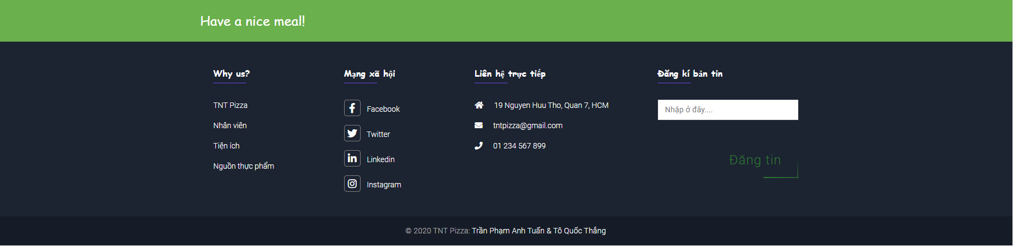

**Pic 3. Footer**

* **Ingredient:** 4 colomn which 1 for information about restaurant, 1 for social network of restaurant, 1 for contact of restaurant and final for customer want to quick review about restaurant.
* **Fuction:** 
  + **First column**: when customer click into them they will go to page Introduce about restaurant.
  + **Second column**: all social network of restaurant for customer easy to find on internet.
  + **Third column**: show contact of restaurent for customer able to respond to restaurant.
  + **Final column**: for customer quick review about restaurant.
  1. **Body**
     1. **Login**

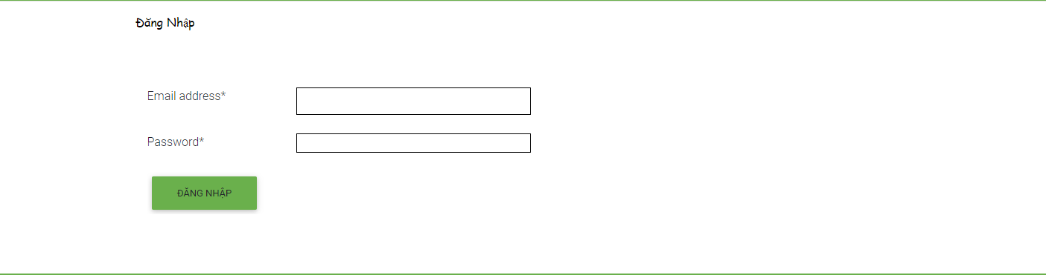

**Pic 4. Login form**

* + **Ingredient:** 2 box for input, 1 button
  + **Function:**
    - **Input box** for user input there email and password was created.
    - **Button Login** for user login into system.
    1. **Register**

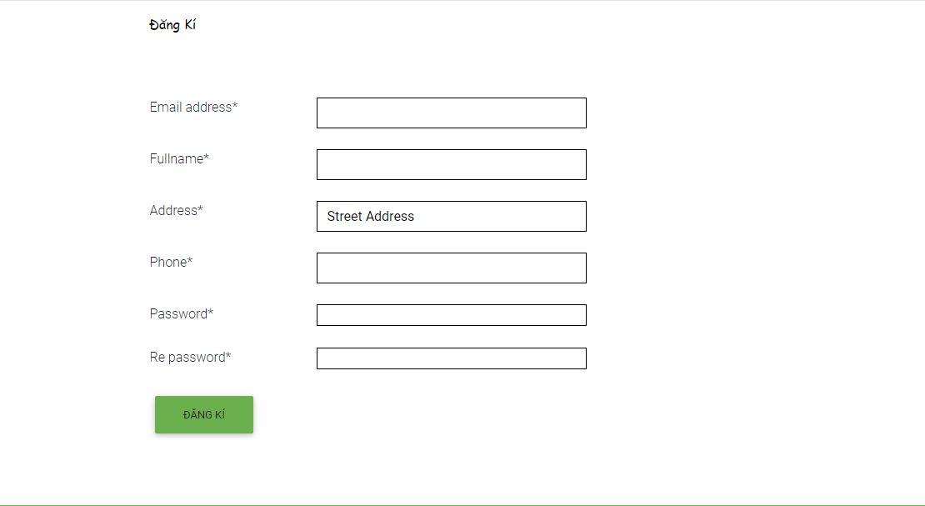

**Pic 5. Register form**

* + **Ingredient:** Input box, button
  + **Function:** 
    - **Input box** for user to enter there information need required to create account which identify what account belong to who.
    - **Button** to confirm when enter all information.
    1. **Trang chủ**

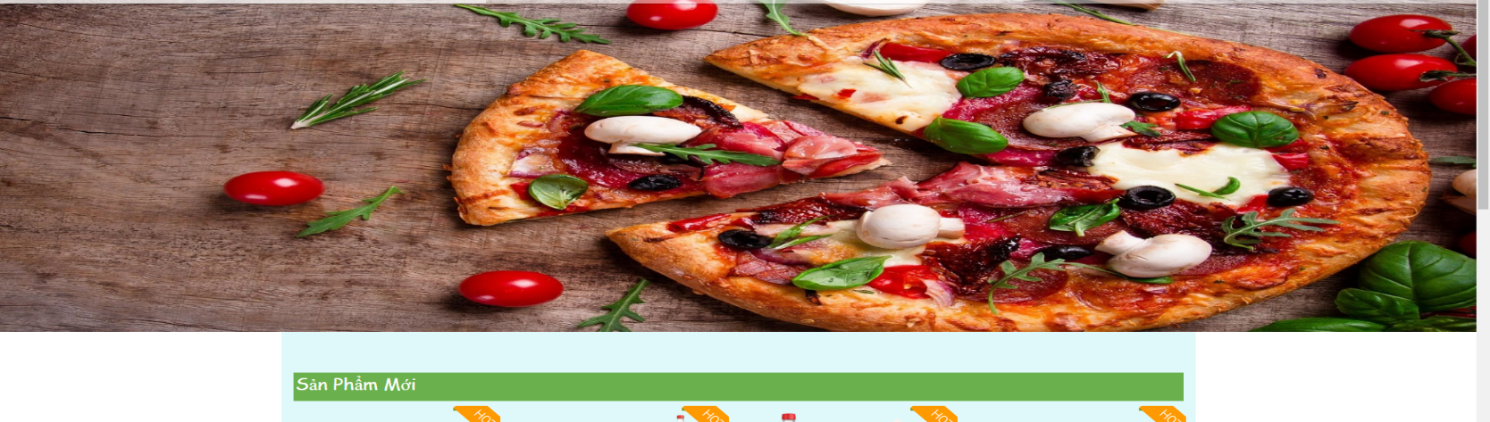

**Pic 6. Slide banner**

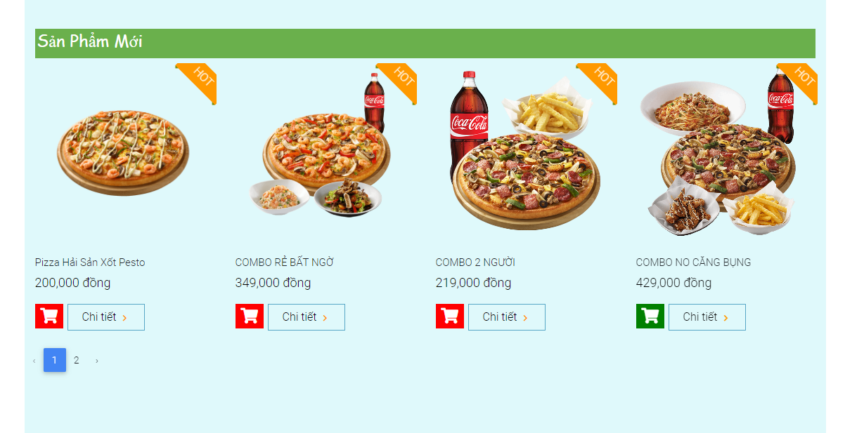

**Pic 7. New product**

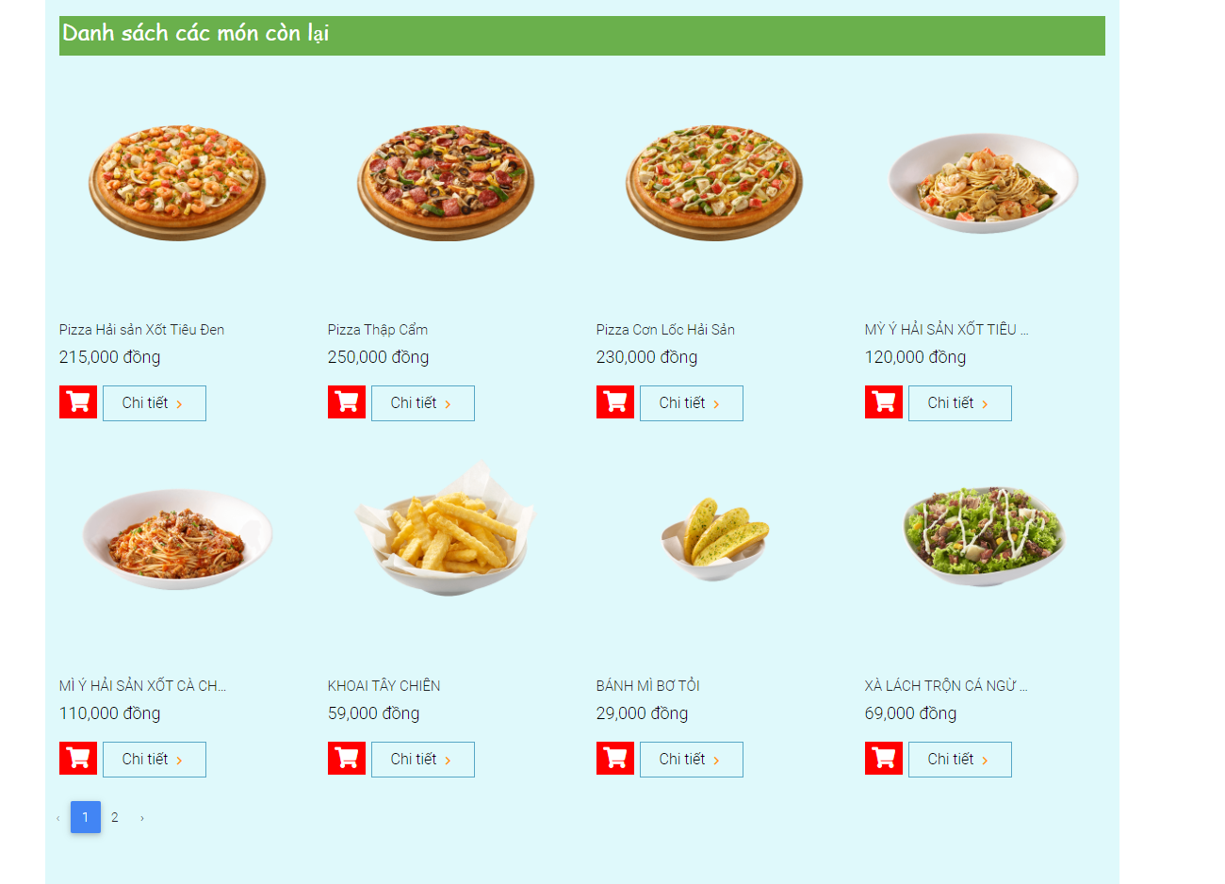

**Pic 8. Other product**

* + **Ingredient:** banner, place to read data from database.
  + **Fuction**
    - **Banner:** Slide of picture about food in restaurant
    - **New product** place to read data of new food in restaurant which include name, price of food and button to add to cart or more details about that food
    - **Other product** same function with new product but read all other food exclude new food.
    1. **Loại sản phẩm**

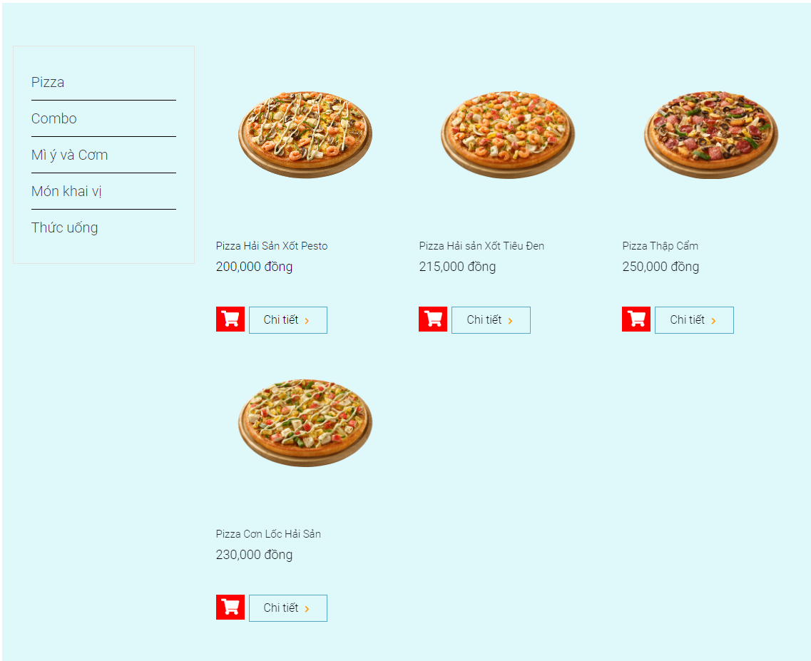

**Pic 9. Type of food**

* + **Ingredient:** list and place to read data of that type food
  + **Function:**
    - **List** show all type of food in menu of restaurant for customer to choose which they like
    - Food show depend what type of customer was choose to see which include name, price of that food and button to add to cart or more details of that food.
    1. **Chi tiết sản phẩm**

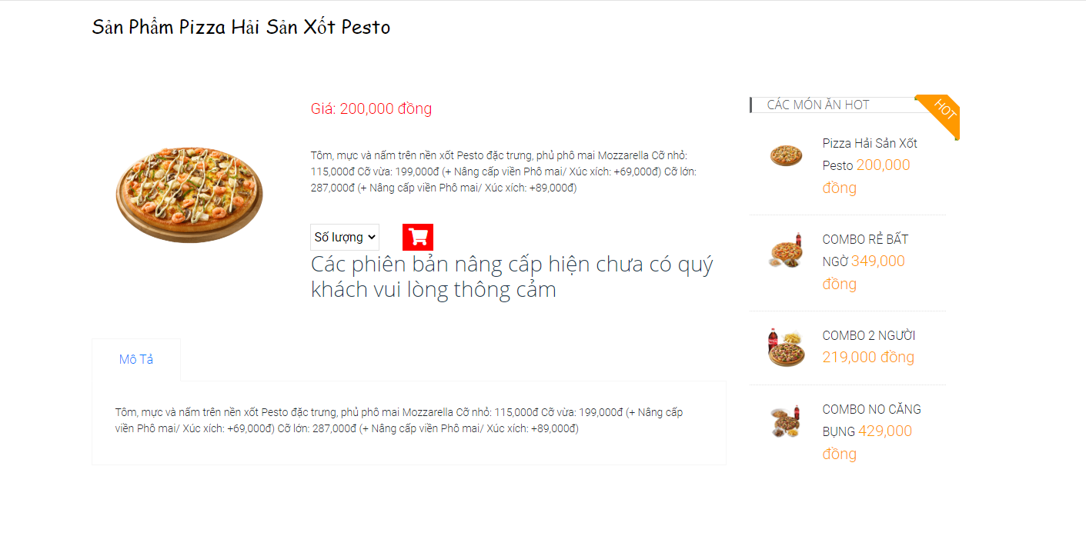

**Pic 10. Details product**

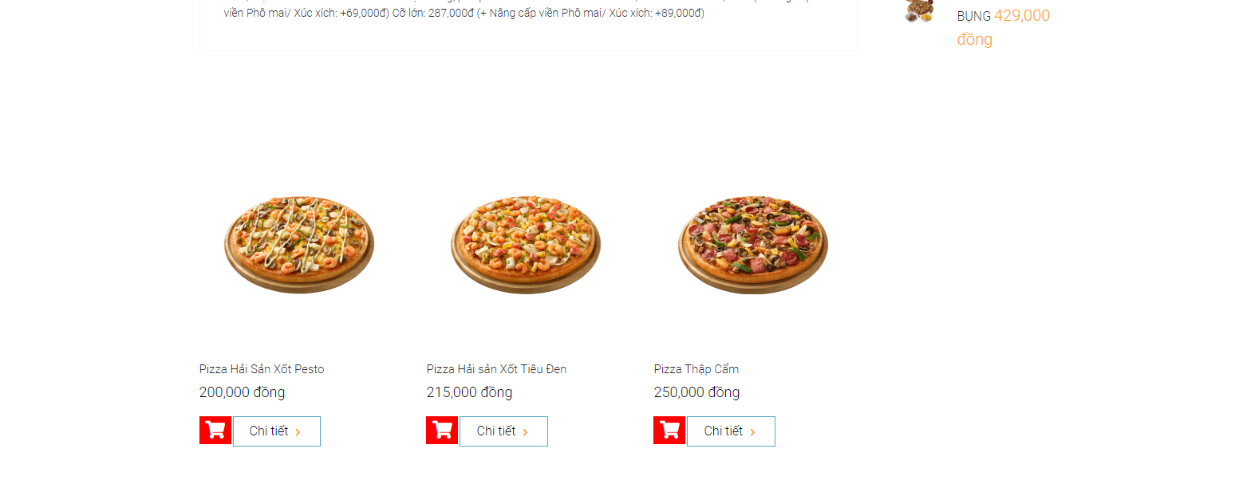

**Pic 11. Other product**

* + **Ingredient:** have 3 part
    - Show detailsof product was choose by customer.
    - Show hot choose which was order many time by other customer.
    - Show other product which have same type which product was choose by customer.
  + **Fuction:** Show more information about product which was choose by customer.
    1. **Giới Thiệu**

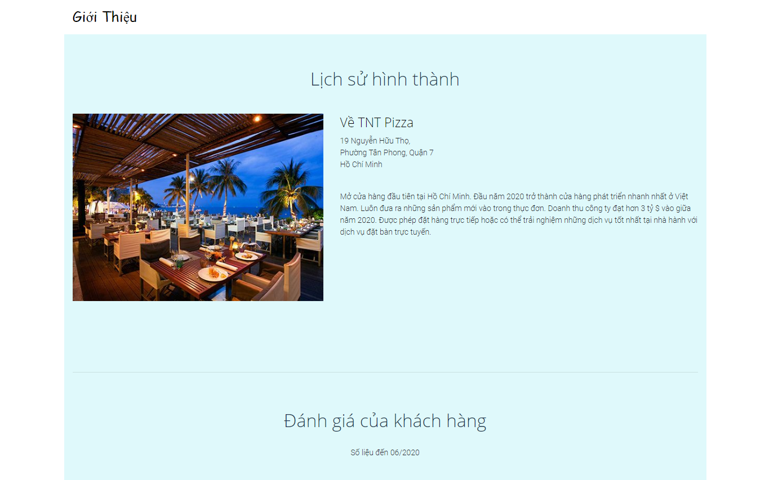

**Pic 12. Process established**

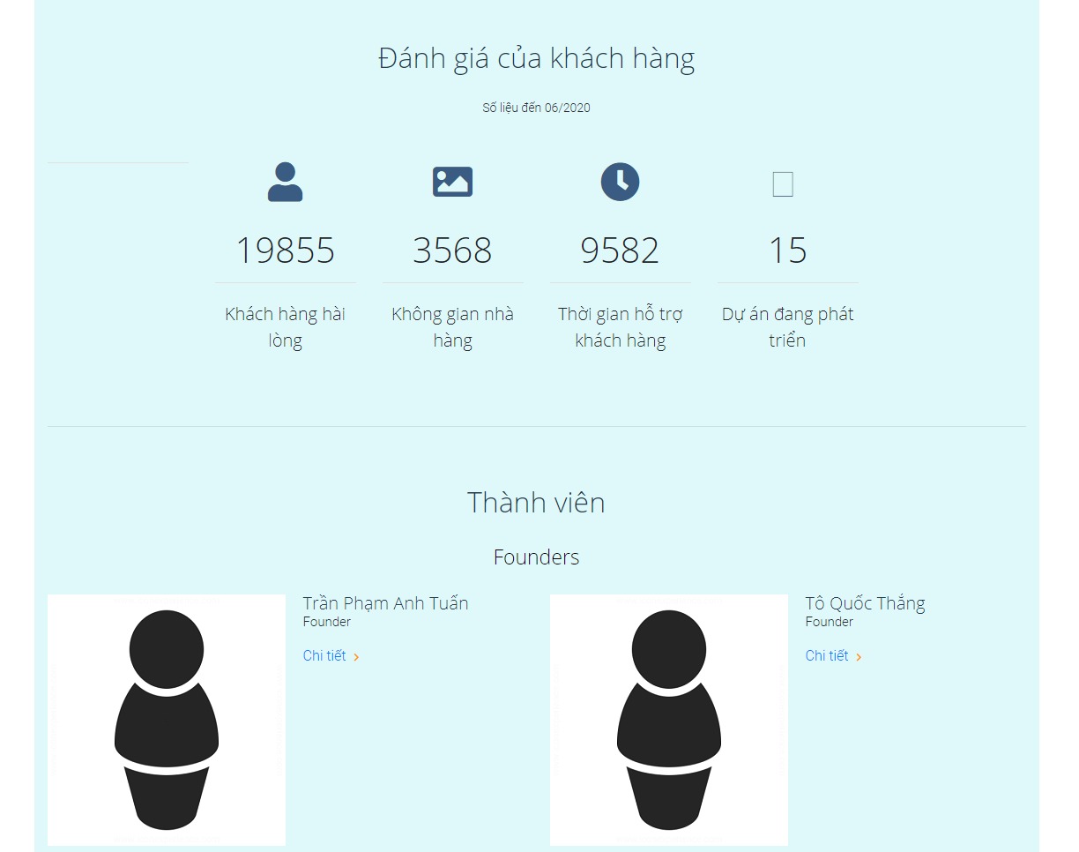

**Pic 13. Coder**

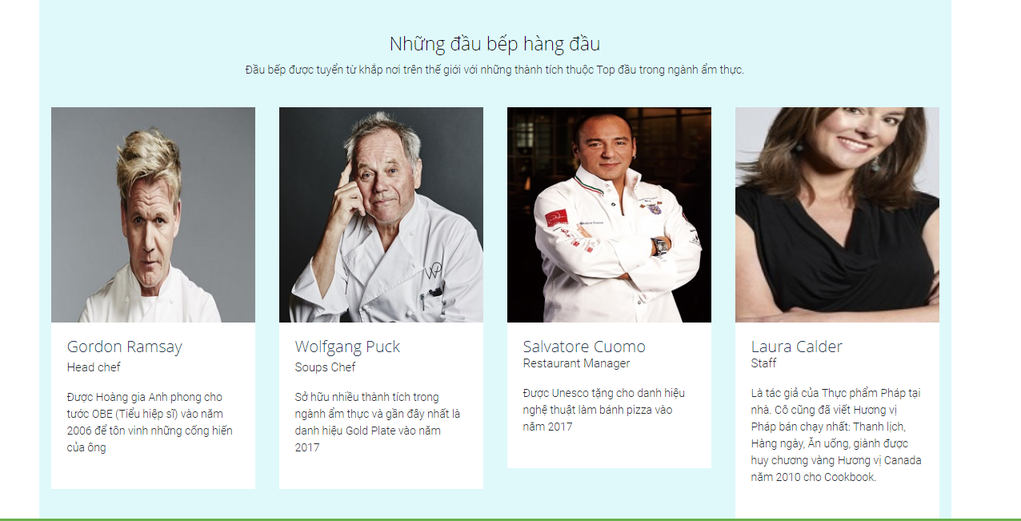

**Pic 14. Staff in restaurant**

* + **Ingredient:** text view
  + **Function:** Show information about restaurant for customer who want to know more clearly.
    1. **Liên hệ**

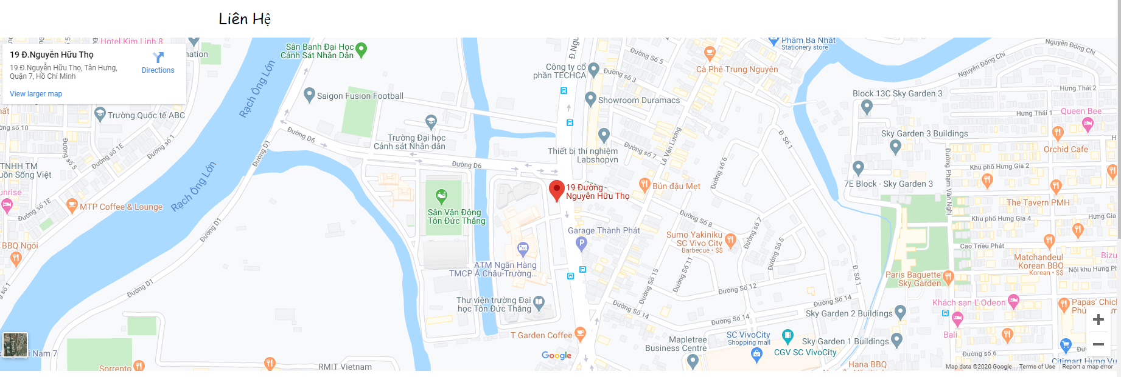

**Pic 15. Map**

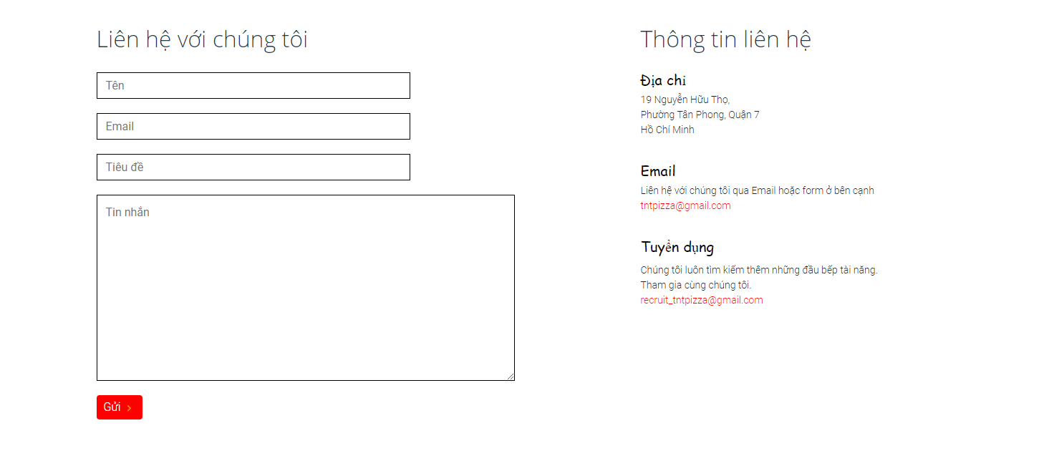

**Pic 16. Contact form**

* + **Ingredient:** iframe, input box, button
  + **Function:**
    - **iFrame** to show the location of restaurant on google map for customer easy to find.
    - **Input box** for customer to input what they want restaurant to improve in the future.
    - **Button** to send what they input to restaurant.
    - Show address of restaurant, email and recruit email for customer if they don’t want to contact thought form.
    1. **Đặt bàn**

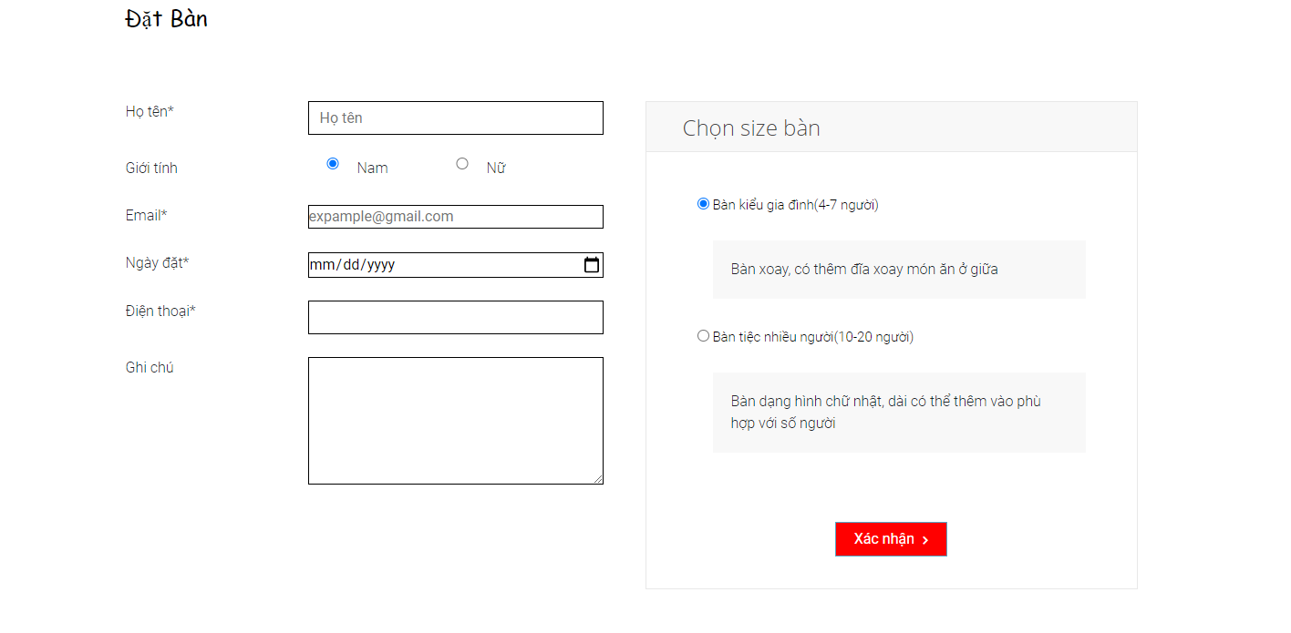

**Pic 17. Book table online**

* + **Ingredient:** input box, button
  + **Fuction:**
    - **Input box** for customer to input there information required to book table.
    - **Select option** for customer to choose what size of table they want to book.
    - **Button** to send.
    1. **Giỏ hàng**

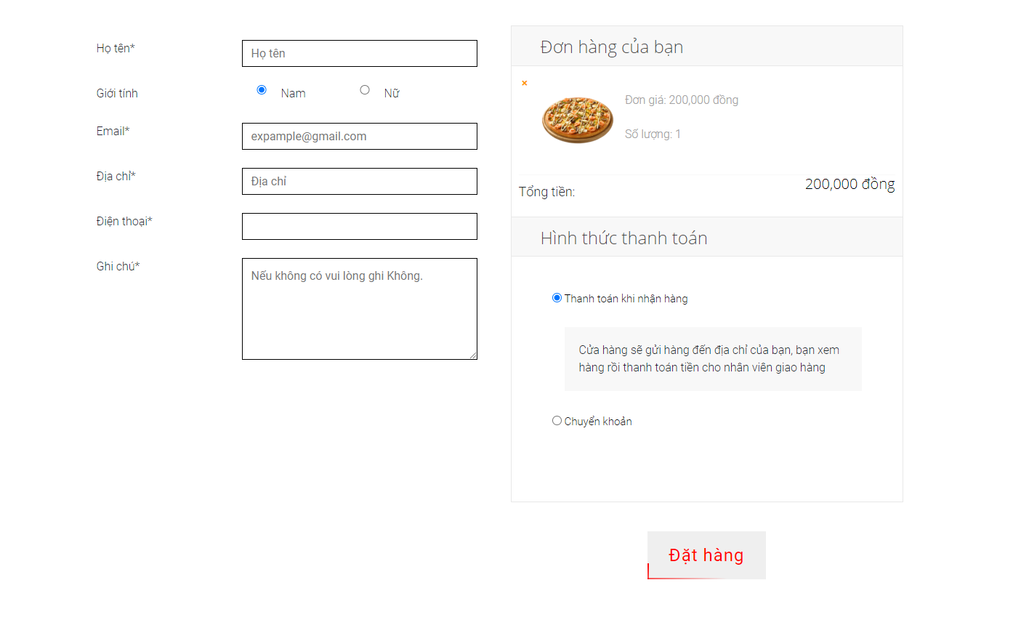

**Pic 18. Cart**

* + **Ingredient:** input box, place to read data, button
  + **Function:**
    - **Input box** for customer to input there information before purchase.
    - All food was add by customer will show with quantity and total price of all food
    - Select option for customer to choose which way they want to purchase.
    - **Button** to confirm purchase.
    1. **Nhà bếp (Check bếp)**

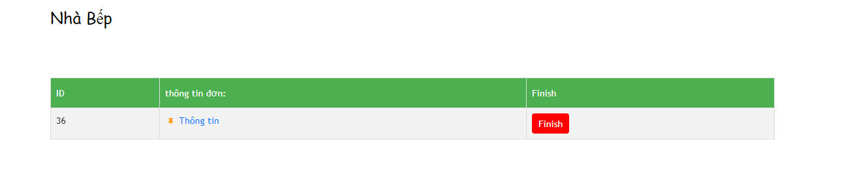

**Pic 19. Order**

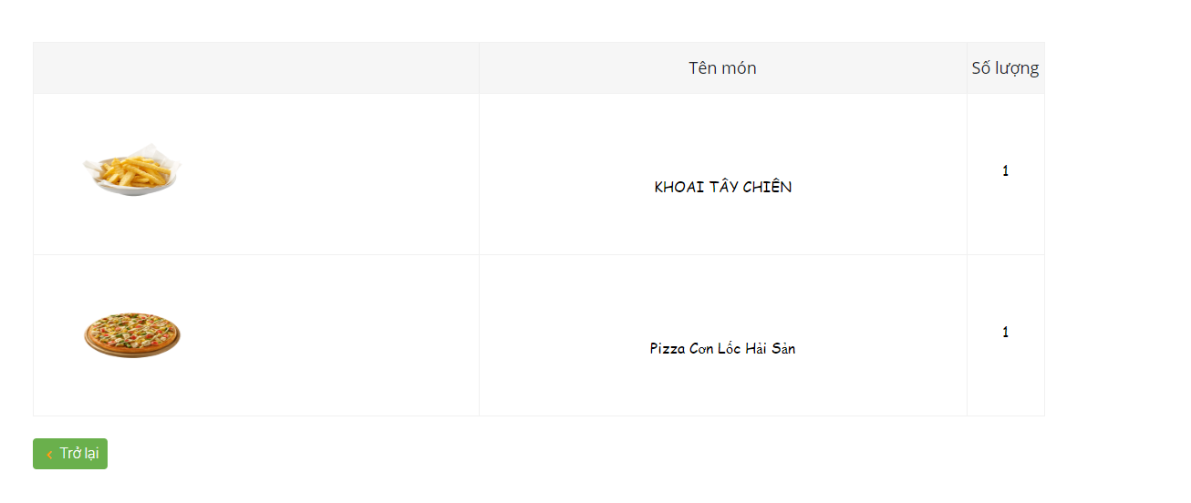

**Pic 20. Food need to make**

* + **Ingredient:** table, button
  + **Function:** 
    - **Table** including orders that have been successfully paid and when click it staff can see what food they need to make.
    - **Button** to inform other department when all the dishes in the bill are done

1. **Code & link website**

* **Github:** <https://github.com/anhtuan3683242/TNT-Pizza>
* **Link website:** <https://pizzahousetnt.000webhostapp.com/>

1. **Conclusion**

|  |  |
| --- | --- |
| **Good** | **Bad** |
| Friendly and basic interface.  The input fields are controlled to avoid information errors when being put into the database.  Support online ordering.  Has a table reservation function for guests.  Sign in function for restaurant staff to manage orders that need to be cooked. | The layout is still basic, not causing special points compared to other restaurant websites  There is no admin system dedicated to admin  Have not updated the transfer payment method |

Through this final project, my team feels that using the laravel framework to make a website makes it easier to create a website or blog online. It helps my team spend less time instead of more designing and developers can spend that time focusing on coding the features available on the framework.

By using Laravel, I feel that Laravel can make my team easy to use, and laravel is built according to the MVC model that can make our project streamlined code while making the submission display code much cleaner than 100% PHP code. However, the updated versions of laravel are not seamless, making the code upgrade easy to break.

Currently, Laravel is the strongest competitor in the simple PHP ecosystem because it includes the features needed to build modern web applications. Therefore, it is a clear and efficient framework, with simple syntax that builds great applications.

1. **REFERENCES:**

https://www.tutorialspoint.com/laravel/index.htm

<https://www.w3schools.com/>

<https://www.youtube.com/watch?v=HY7M7PuyP1Q&list=PLzrVYRai0riS_Y2L0Ox_gUL9UjPDL8p2i>

<https://getbootstrap.com/docs/4.3/components/modal/>

<https://laravel.com/docs/7.x>